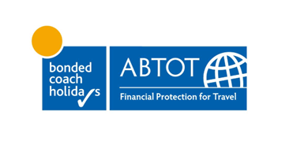

To whom it may concern

Re M H Elcock & Son t/as Elcock Reisen
We refer to the above Member of BCH ABTOT, who we regret to confirm has ceased trading on 30 August 2023.
Thank you for your enquiry concerning a booking made by you to M H Elcock & Son t/as Elcock Reisen using your credit card.
You will need to submit your claim to your card issuer in the first instance as your card issuer has liability in the UK under the Consumer Credit Act to refund you or if you reside in the EU under EU Directive 2008/48/EC on consumer credit agreements.
Under the Consumer Credit Act or EU Directive 2008/48/EC you can claim against your card issuer for the full cost of the purchase (not just the amount on the card), for example, where the deposit was paid on your card and any further payments were made by another means.
In order for your claim to be considered you should forward this letter on to your credit card company along with copies of your other M H Elcock & Son t/as Elcock Reisen documents requesting that they consider your claim. Failure to do so may result in your claim being significantly delayed.
Please contact us again for assistance should you have any difficulties.
Yours sincerely
BCH ABTOT Limited

