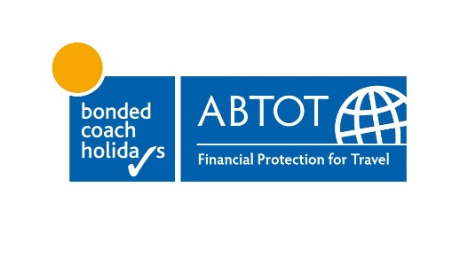

To whom it may concern

Re: Filers Travel Limited
We refer to the above Member of ABTOT, who we regret to confirm has ceased trading on 30 August 2025.
As your payment was made to Filers Travel Limited using a Debit or Credit Card you should submit your claim to your card issuing bank for a chargeback in the first instance. Your bank would have subscribed to the Visa/MasterCard scheme rules, which mean you have the right to request a chargeback against the merchant's bank if you don’t receive services paid for using your Debit or Credit Card.
In order for you to make a claim you will need to ensure that you provide a copy of this letter to your card issuing bank along with your other Filers Travel Limited booking documents to allow them to process your claim.
Please Note: There is a time limit on making a claim with your card issuing bank, this is typically 120 days from the date at which you become aware of a problem and 540 days from the transaction date.
Should you encounter any difficulties with your bank we would suggest that you contact the Financial Ombudsman Service for further advice and assistance through their website www.financial-ombudsman.org.uk or by telephone on 0800 0234567.
Should you require any further assistance after following the above steps then please do not hesitate to contact us.
Yours sincerely
Bonded Coach Holidays c/o ABTOT Limited

