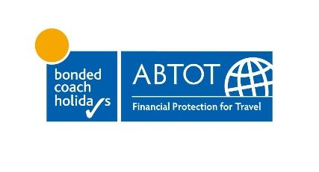
FAQs for Filers Travel Limited claims
- Which holiday companies are covered by the ABTOT Bond?

- Filers Travel Limited

- What types of holidays are covered by the ABTOT Bond?
Bookings that are protected
Only coach package holidays are protected by the ABTOT bond. These must be more than 24 hours in duration and include accommodation and an overnight stay and other ‘tourist service’. The following packages are protected:
- Coach holidays including overnight trips in the UK
Bookings that are not protected
The following types of bookings are not protected by the ABTOT bond and you need to contact the administrator to make a claim [TBC]
- Day trips and excursions
- Travel insurance costs
- Gift Vouchers and vouchers given as a goodwill gesture. (see Vouchers below)

- How do I make a claim?
Credit card bookings for UK and EU customers
If you have paid for your booking by credit card and the value if £100 or more, you need to contact your credit card provider and claim under s.75 of the Consumer Credit Act 1974, or the EU equivalent under EU Directive 2008/48/EC on consumer credit agreements . We have a letter on the website to help with this claim.
Your credit card company cannot refuse to make this refund to you – it is your absolute right provided the payment was over £100. If you have made a part payment of the total costs by credit card, (e.g. just your deposit), provided this is over £100 you can claim the full cost of your holiday under s.75 or its equivalent EU legislation.
It is often the quickest and most straightforward way to recover monies.
Debit card bookings for UK and EU customers
If you paid by debit card (or by credit card where the value is under £100), you need to contact your card issuing bank and make a chargeback claim. We have a letter on the website to help with this claim. You have 120 days to make a chargeback claim.
If your bank asks for more information in order to process the chargeback, then get in touch with ABTOT to help you. If your bank refuses the chargeback, you will need written confirmation of this from your bank before you contact ABTOT to seek a refund under the bond. We understand that it is sometimes quite difficult to get in touch with your bank, however you do need to show written evidence that you have been in contact before ABTOT will be able to help you.
Cash, BACS, IBAN or cheque bookings
You will need to complete a claim form. Please download a claim form from the website and email us at claims@abtot.com with the supporting documentation. You will need proof of your booking and payment as supporting evidence.
- How long do I have to make a claim?
You have six months to lodge a claim so there is plenty of time. We understand that a lot of people are still very restricted in movement and in getting help from friends or family due to the Coronavirus restrictions. We are taking this into account and have made sure there are plenty of ways to get information to you.
If you need to do a chargeback you have 120 days to do this (4 months) so should do this without delay. You will still have time to contact ABTOT for further help if needed once you have contacted your bank.
- Can I claim back my travel insurance premiums?
Unfortunately travel insurance premiums are not covered by the bond.
- Why are gift vouchers not covered?
Gift vouchers or goodwill vouchers which have not yet been used or exchanged for holidays are not covered by The Package Travel and Linked Travel Arrangements Regulations 2018 and are not recoverable.

